North Lincs Health & Safety Group - COVID-19 Update No 8 Friday 29th May 2020

Roadmap to lift restrictions step-by-step
The Government has a carefully planned timetable for lifting restrictions, with dates that should help people to plan. This timetable depends on successfully controlling the spread of the virus; if the evidence shows sufficient progress is not being made in controlling the virus then the lifting of restrictions may have to be delayed.

Test and Trace
The test and trace system has gone live this week. Full details of how it works, what you and the rest of your family need to do, are available at https://www.gov.uk/guidance/nhs-test-and-trace-how-it-works

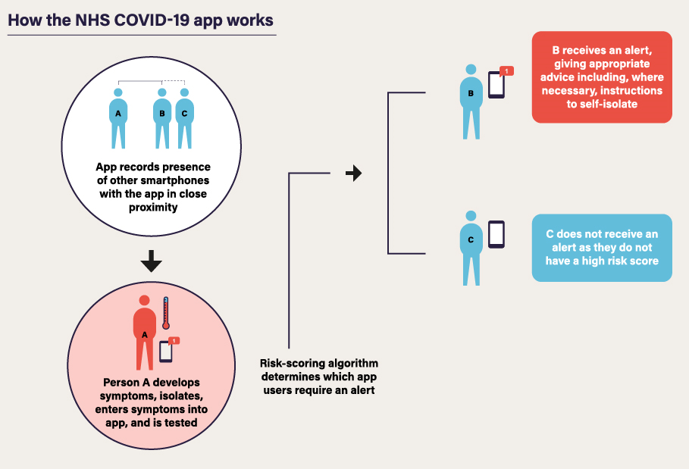

Further information ‘how the app works, can be found on the NHS Website.

Lending a hand
The response of individuals, communities, charities and businesses across the United Kingdom - to step in and lend a hand to support the national effort - has been tremendous. There are still opportunities to support the COVID-19 effort even more directly.
To find opportunities to volunteer with charities or the NHS, please see: https://www.gov.uk/volunteering/coronavirus-volunteering
To offer business support, such as equipment, services or expertise, please see: https://www.gov.uk/coronavirus-support-from-business

Coronavirus – Back to Work Webinar is being re-run on Thursday 4th June 2020 at 14:00
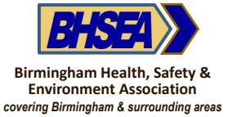
The webinar is being hosted by the Birmingham Health, Safety & Environmental Association and is free for all Safety Group’s members to attend.
The webinar includes practical guidance and best practice for implementing the government guidelines on coronavirus infection controls and will explore:
- A risk-based approach to implementing risk controls that are both effective and practical
- Best practice case studies
- Ideas for making your exit from the lockdown effective whilst minimising disruption
- Places on this free training webinar are limited and allocated on a first come basis.
If you missed the webinar on 21st May and are interested in attending then please drop me an e-mail and I will forward the link for you to register.

The North Lincs Health & Safety Committee has been busy in the background during the pandemic, our Media and Website Co-ordinator is currently re-designing the website. These improvements will give us the facility to hold our own webinars.
Visit www.nlhsg.org.uk for a look round. It is still a work in progress, but if you have any comments or suggestions for the committee the ‘contact us’ page is fully working.
For the latest information about the Coronavirus Pandemic
Government advice:
https://www.gov.uk/guidance/coronavirus-covid-19-information-for-the-public
https://www.gov.uk/government/publications/guidance-to-employers-and-businesses-about-covid-19

NHS advice: https://www.nhs.uk/conditions/coronavirus-covid-19
NHS 111 on line advice: https://111.nhs.uk/covid-19 or Telephone 111

Further guidance and support can be found at the following
www.citizensadvice.org.uk Phone: Advice Line: 03444 111 444
www.mind.org.uk Phone: 0300 123 3393
www.anxietyuk.org.uk Phone: 0300 123 3393
www.samaritans.org.uk Phone: 116 123 (free 24-hour helpline)

STAY ALERT > CONTROL THE VIRUS > SAVE LIVES

