North Lincs Health & Safety Group - COVID-19 Update No 6 Friday 1st May 2020
STAY AT HOME > PROTECT THE NHS > SAVE LIVES

The Prime Minister confirmed in Thursday’s Press Conference that the UK are past the peak and will issue a statement next week of how to continue to suppress the disease and at the same time re-start the UK economy.

How to protect your home and business from Cyber Crime
Measures announced over recent weeks to deal with coronavirus (COVID-19) have seen our day-to-day life drastically changed – we are spending more time at home and online. Unfortunately, criminals will use every opportunity they can to scam innocent people and their businesses.

Scammers can contact you by phone, email, text, on social media, or in person. They will try to trick you into parting with your money, personal information, or buying goods or services that don’t exist.

https://www.gov.uk/government/publications/coronavirus-covid-19-fraud-and-cyber-crime/coronavirus-covid-19-advice-on-how-to-protect-yourself-and-your-business-from-fraud-and-cyber-crime this guidance explains simple steps you can take to protect yourself and your business against fraud and cybercrime and where to get help.

Safety Groups Working Together
All local Safety Groups are current looking for ways to keep in touch with their members while meetings cannot be completed in the usual way. Our colleagues in Birmingham have opened up their webinars to other safety groups members free of charge.
If you are interested in joining one of the sessions, please contact me and I will sent you the log-in details as soon as they are released.
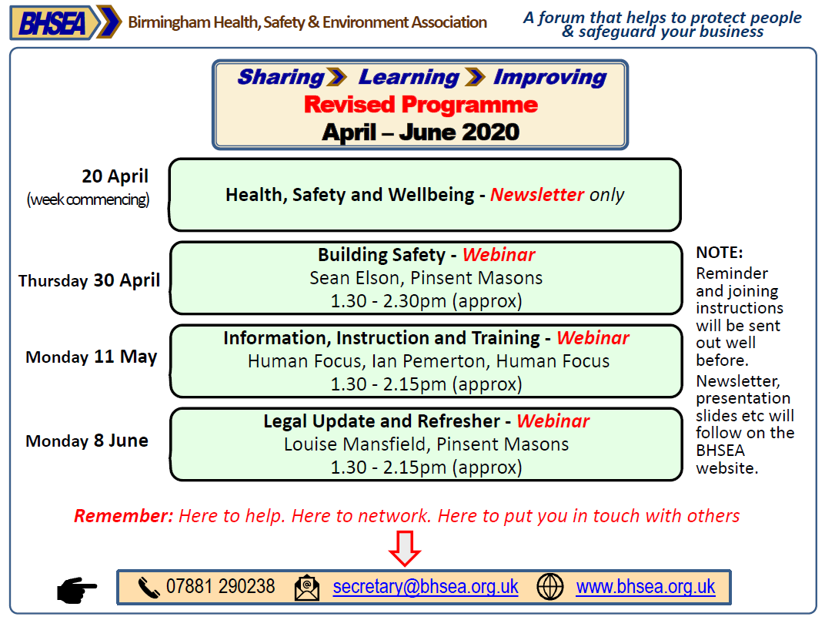

Why not take up a new challenge during the lockdown period
- Is your brain needing stimulation?
- Have you tackled all the DIY jobs around the home?
- Are you looking for something different to try?
The Open University has 50 years’ experience delivering flexible learning and offer over 900 courses on-line free of charge. Making the decision to study can be a big step but with beginner level through to advanced learning courses.
On completion of the course you receive a statement of participation which could be put towards your Continual Professional Development.
For more information about the free courses available and the study options follow: https://www.open.edu/openlearn/free-courses/full-catalogue
During these unprecedented times, we must be mindful that employees have the potential for lapses in concentration.
It is also worthwhile considering that as some employees may be absent from work because of self-isolating / shielding that staff still working may try and still complete job roles in the same amount of time as it would normally take 2 or more people.
It is important to remember that Risk Assessments should be reviewed either following an incident or following significant changes in the workplace. The COVID-19 pandemic would fall into this category, where changes to operations have been necessary..
The safety of colleagues must not be compromised.

For the latest information about the Coronavirus Pandemic

Government advice:
https://www.gov.uk/guidance/coronavirus-covid-19-information-for-the-public
https://www.gov.uk/government/publications/guidance-to-employers-and-businesses-about-covid-19

NHS advice: https://www.nhs.uk/conditions/coronavirus-covid-19
Advice for travellers: https://www.nhs.uk/conditions/coronavirus-covid-19/advice-for-travellers
NHS 111 on line advice: https://111.nhs.uk/covid-19 or Telephone 111

The extended COVID‐19 lockdown measures may increase levels of anxiety and worry for many different reasons. It is important to remember that these feelings and concerns are perfectly normal and there are numerous support networks able to provide support, contact details for a few of these are detailed below.

www.citizensadvice.org.uk Phone: Advice Line: 03444 111 444 (Monday to Friday, 9am to 5pm)
www.mind.org.uk Phone: 0300 123 3393 (Monday to Friday, 9am to 6pm)
www.anxietyuk.org.uk Phone: 0300 123 3393 (Monday to Friday, 9am to 6pm)
www.samaritans.org.uk Phone: 116 123 (free 24-hour helpline)

