**PRESS RELEASE**

12rd September - for immediate release

**“Daddy, people die doing that”**

One sentence from farmer Gareth Sproule’s daughter was all it took to change his normal practice when mixing slurry from dangerous to safe.

So moved was he by this that he posted the message below on Facebook.

“Tonight for the first time ever I haven’t went into the shed while pumping slurry….. why? Because my 4 year old daughter when she heard what I was going to do said to me ‘No daddy people die doing that’…. Funny how it takes a 4 year old to drive home a message!”

Gareth is related to Northern Ireland Safety Group’s Jimmy Fenton, and he realised this message was a powerful reminder to all in the farming sector.

The Facebook post (now blown up to an A2 size poster) forms part of the Group’s stand when promoting farming safety and health at agricultural shows and is a welcome addition to the Farm Safe information packs we give out.

“We see people reading the message and then reflecting whilst their kids are learning about farm safety” said Jimmy. He went on to say “Farming safety is an integral part of what we do and we’re delighted that Industry Training Services supports us to deliver this by demonstrating hands on first aid (as well as how to use a defib) to farmers and their families”.

For more information on how NI Safety Group promote occupational health and safety visit [www.nisg.org.uk](http://www.nisg.org.uk)

Ends

**Notes to Editors:**

1. For media Enquiries please contact Ernie Spence, NI Safety Group Secretary on 028 9336 8928/07938 049270 or email [info@nisg.org.uk](mailto:info@nisg.org.uk)
2. Hi res photo downloads at the link below

<https://spaces.hightail.com/space/aq0SPJeSF8>

Caption Jimmy Fenton (l) with George Sproule and the Facebook message.

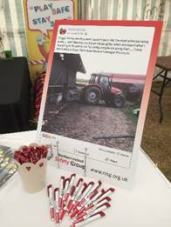

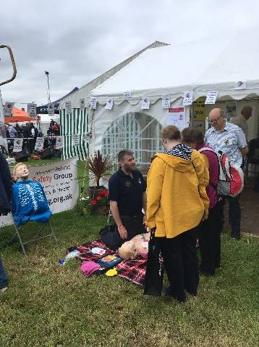Caption – Hands on first aid demonstration

1. About Northern Ireland Safety Group

Run by a dedicated committee of volunteers (all of whom are safety professionals) our mission as an organisation is to promote occupational safety and health.

Our work continues to push boundaries and has earned us a reputation as an innovative and forward thinking health and safety networking group.

With over 300 organisations as members in the Group’s influence stretches wide throughout both the sector and the Province. And it is only through organic growth that we can further our mission of promoting safety and health at work.

Northern Ireland Safety Group is a Charity registered with the NI Charities Commission.

Northern Ireland Safety Group, 13 De Courcy Avenue, Carrickfergus, BT38 7LJ