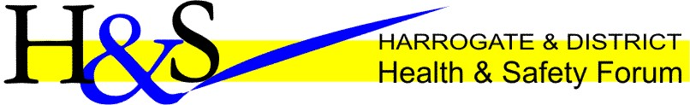

HEALTH AND SAFETY EVENT
The Pavilions, Great Yorkshire Showground,
Harrogate HG2 8NZ

Wednesday 6th March 2019

Workplace Behavioural Safety, Culture and Communication

Registration & Exhibitors from 12.00 – 13.00

Presentations start at 13.00

Close 16.00

This event aims to give those attending a better understanding of the requirements of a behavioural safety programme and how if implemented correctly can positively influence your workplace Health and safety standards. It will also show how this can also affect workplace culture, explore the role of the safety representative and ways on how to communicate Health and safety effectively.

Managing human failures is essential to prevent major accidents, occupational accidents and ill health, all of which can cost businesses money, reputation and potentially their continued existence. People are involved in all aspects of work, which is why HSE recognises the importance that human factors can play in helping avoid accidents and ill-health at work. This not only improves their health and safety but often ensures a better managed, more effective organisation.
Not all risks can be engineered out of the work environment. Even with the best plans, procedures and systems in place, individuals at work still take short cuts and make mistakes. Sometimes risk-taking behaviour is intentional, for whatever reason. In other cases, risks may be taken due to a lack of understanding about a particular hazard, associated controls or inadequate training. To individual workers, such risk-taking can result in injury, ill-health and fatalities. To the organisation, some of the many costs can include lost time, damage to machinery, litigation, and prosecution. If unchecked, these costs can escalate.

Statistics show that unsafe acts are the most common cause of workplace accidents. Despite the introduction of training programs and safe work practices and procedures, controlling unsafe acts has proven to be difficult.
It is estimated that in up to 80 per cent of all work place – related accidents, the behaviours of employees – in the form of acts or omissions – is a contributing factor
The reason for this is that unsafe acts involve the Human Factor, that is, they occur as a result of people’s attitudes and behaviours.

Behavioural Safety offers a way to reduce the incidence of unsafe acts by modifying people’s behaviours and improving their attitudes towards safety.

The event will be suitable for Business owners and employees, SME’s, Directors, HR personnel, Managers, Health and Safety managers and practitioners Workplace Safety Reps and those with a general interest in Health and Safety

Event Programme

13.00 – 14.00 - Workplace Behavioural Safety
Behavioural safety is the application of behavioural research on human performance to the problems of safety in the workplace. The presenter will provide an understanding of Behavioural Safety how a behavioural base safety programme works
David Brown – Health and Safety consultant – DBRSM Safety Management

14.00 – 14.20 - Tea Break and exhibitors
14.20 – 15.05 - Workplace Safety Culture – Case study

An organisation’s culture can have as big an influence on safety outcomes of the safety management system. The presenter will describe how a positive safety culture can benefit organisations (Presenter to be confirmed)

15.05 – 15.30 - The role of the ‘Safety Representative‘

David Houlgate – Health and Safety representative -Harrogate Borough Council

15.30 – 16.00 - Communicating Health and Safety

To achieve success in health and safety management, there needs to be effective communication up, down and across the organisation. The presenter will look at Key actions in communicating effectively and will look at a range of communication methods.
James Wyse-National Sustainability & North Area Health & Safety Lead - EEF the manufacturers’ organisation

Q&A / End
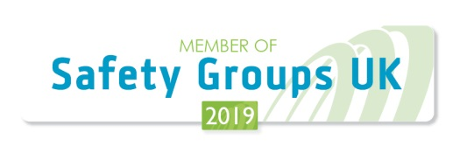

https://www.eventbrite.co.uk/e/workplace-behavioural-safety-culture-and-communication-tickets-54914026331

