Safety, Health & Wellbeing Live - Manchester Central May 2022 Chairman’s Report
I am delighted to report on the recent HSW Live event in Manchester on 23rd and 24th May where SGUK were on stand 222, this is a short story about the journey. As we all know, we are Event Partners with Whatelse Events, and this story is testimony of a good relationship and Partnership
I must admit, that I am not and have never been a lover of exhibitions, especially the ones that are a mere platform for selling PPE, too much fuss for very little gain and the start of this event was not short of the unexpected.
Firstly, last year, I sold my 5 series BMW Estate within which, there was more storage space for exhibition equipment and accommodation luggage than required for 2 or 3 people, thinking SGUK would not get involved in exhibitions again since the retiral of Mike & Cathy Nixon, so I indulged myself by buying a BMW 4 series convertible. When the time came to prepare for travelling down to Manchester, I panicked slightly thinking I might need to hire a small van or at least a bigger car however, I actually managed to get everything in the car and even had room for a passenger – Yes, everything on the left fitted plus the SGUK pop ups in to that wee car…..
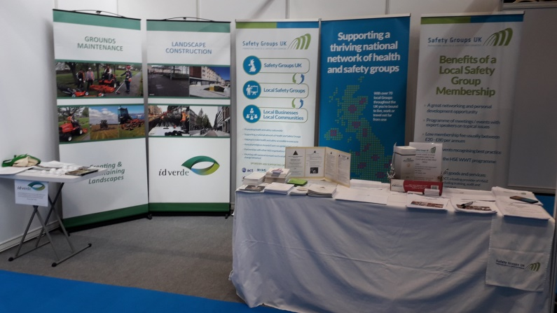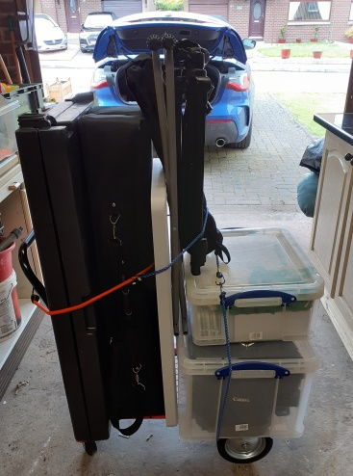
Re the stand itself, after the trauma of the Manchester City traffic on the Sunday (it took me longer driving round the various combinations of road closures in the city centre than it took me to drive from Stirlingshire to the Manchester city centre), but got there in the end. Our dear colleague Phill Jones and his grandson Luke helped unload the car, transport to the stand and build it up all except the 3 new SGUK pop ups which another friend and colleague Sarah Kenny brought and built up for us on the Monday before the exhibition opened. It was a pleasure to eventually get back to the hotel for a nice meal and a couple of pints.
On day 1 of the event, I am delighted to say that we had a number of helpers on the stand, Myself, Phill, Sarah Luke (Phills grandson who also took all the photographs and made a video of the award ceremony), Bob Rajan, Sanjeev Kumar, Carol Stearne of and SCOHSG along with a few of her colleagues, from Northern Ireland, Ernie Spence; Wilson Lambe; Ashleigh Birkettand John Thomson. From Herefordshire, Mike Burge, Phil Chandler and
Adrian Gale. From North Lincs, Emma Crawford and Phil Crawford, From Kent, Mark Curry. Other group related joined us, and joined in the discussions with stand visitors. I particularly mention Stewart Bailey who was also on the local IOSH branch stand. I was so impressed with him that I hopefully encouraged him to get himself nominated by his local group for election to our Board
Our old friends Mike and Cathy Nixon also spent some time with us on the stand, and it was good to catch up with them. Footfall was good and steady throughout the day, and we established many new contacts, some of which were members of local groups and some that would be interested in joining a local group and of the work we do. Helping on the stand for a while was our guest speaker for the awards ceremony Richard Taffs representing a previous Development through Education Award winner Parklands Academy. As well as Richard, we were helped by Ryan Dukes who was representing our latest Award Sponsor idverde Grangemouth Contract who are sponsoring the Lord Cullen Innovation Award at Farnborough in September.
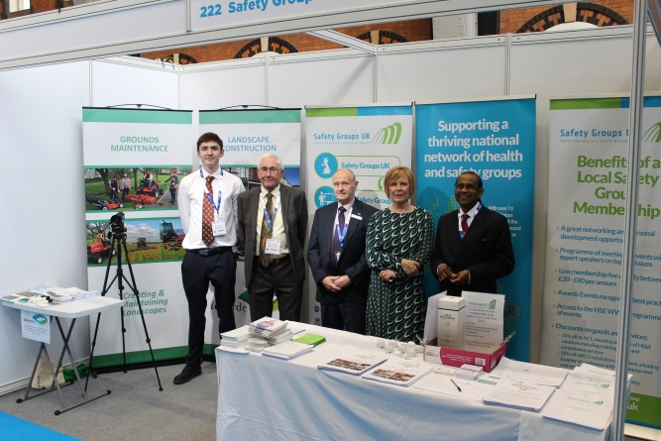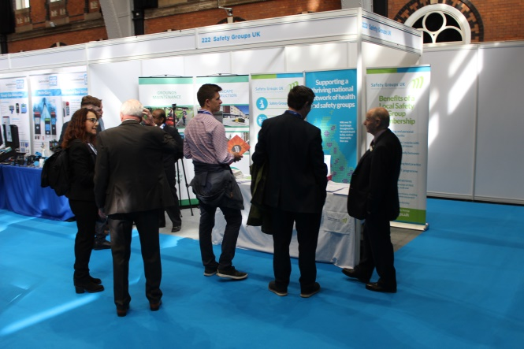
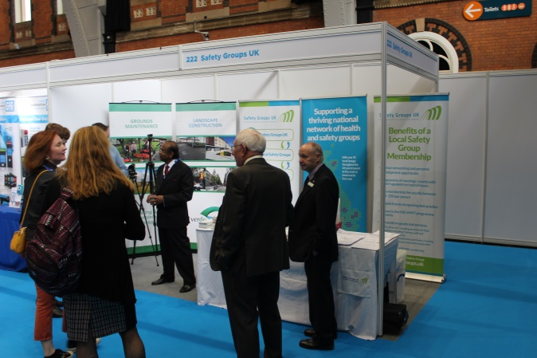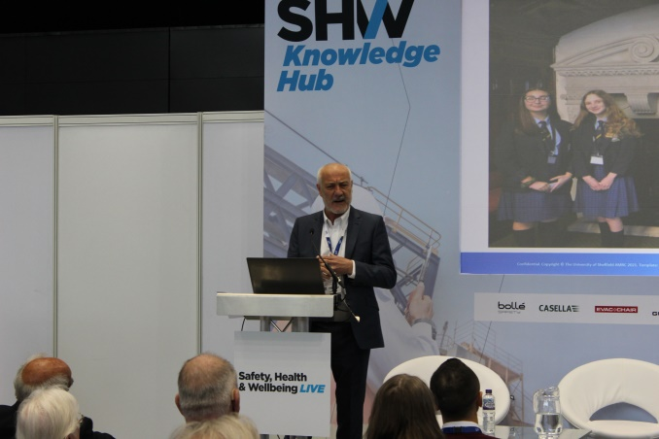
At around mid-day on the first day, we held the ceremony where we presented the Excellence and Outstanding Service Awards. Most of the award recipients turned up to receive their various awards, and those that were unable to attend were either presented locally, or their award was posted to them. Richard and Ryan shared presentation duties, and Richard told a story regarding how come the students of Parklands Academy prepared for, entered and won the SCOS Award as the Top award in the Development through Education Award for 2019 being presented at the Royal Horseguards Hotel in Whitehall London in February 2020. Richard made a pledge, or perhaps it was a challenge, to other entrants that Parklands Academy are seeking to retain the award this year – we wish them good luck. All photographs taken and the video are available for viewing / downloading from the SGUK website. Here are some examples below: Link to the video on You Tube is: SGUK Excellence and Outstanding Awards Ceremony May 2022 part 1 205706 - YouTube When the file is open, click on the round S icon and select Manchester Awards Ceremony, Parts 1, 2, and 3 should play consecutively .

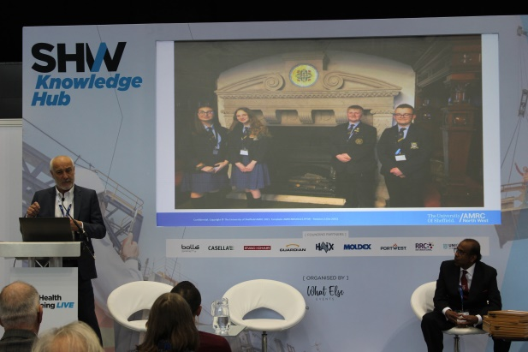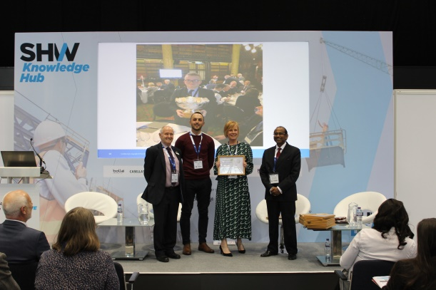
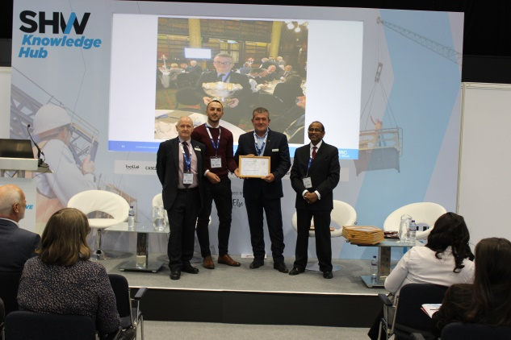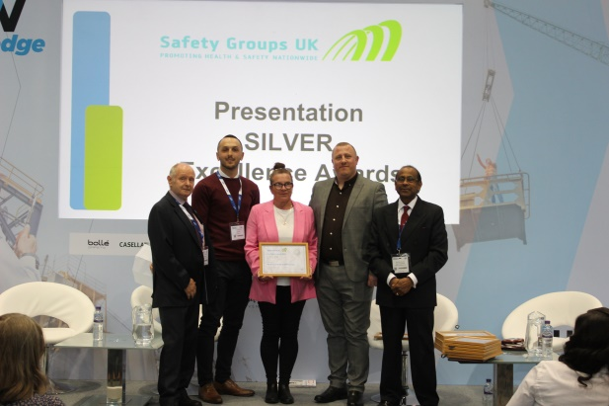
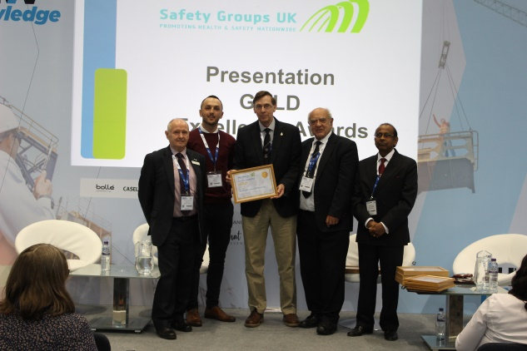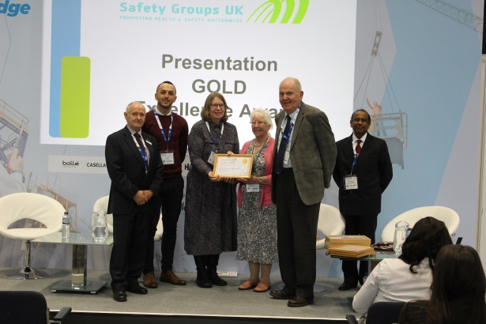
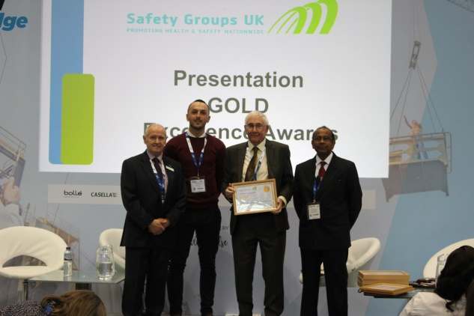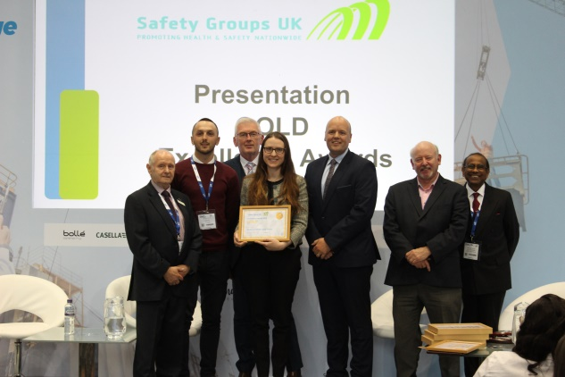

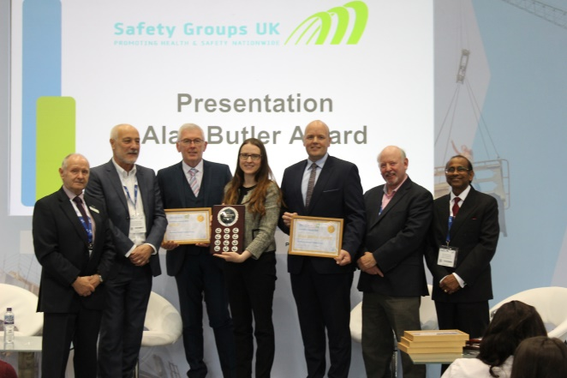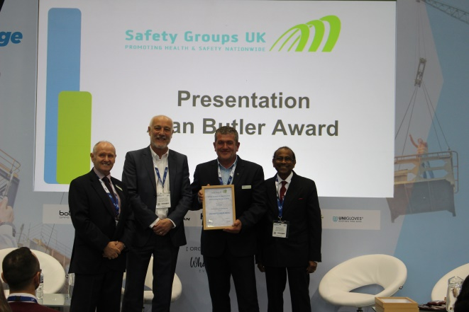
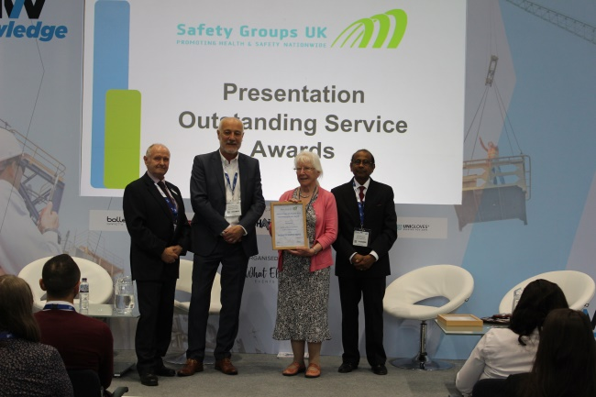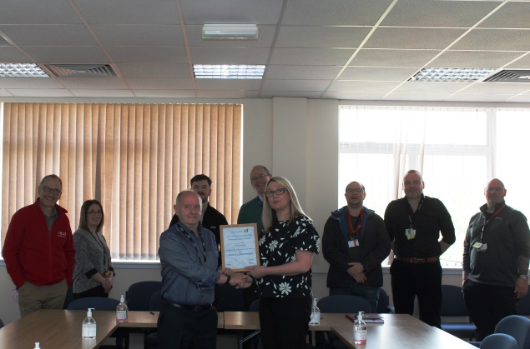
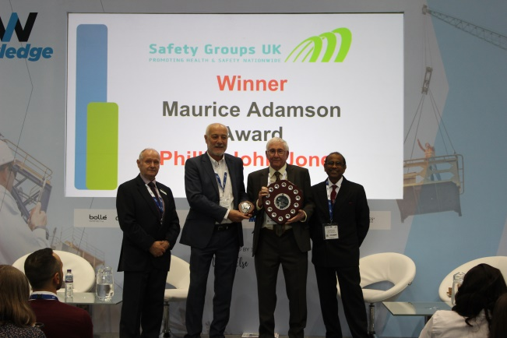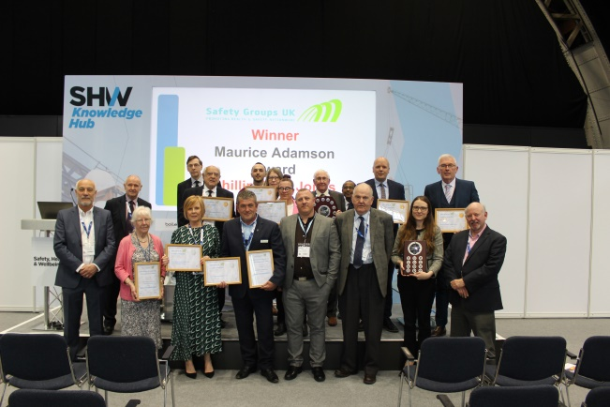

On day 2, it was more of the same, footfall was again steady until just after lunchtime. In addition to a number of new contacts, we enjoyed the company of Stuart Mason from SCOHSG who helped on the stand throughout the day.
As most may already be aware, I donated a bottle of one of the Finest Popular Speyside Single Malt Whiskies, ‘Old Pultney’, and Phill Jones donated a top of the range lap top bag as prizes for a business card draw. I am pleased to say that an exhibitor at the event who is also interested in her company joining a local group, Kate Hydes of Peritas Health Management of Brighouse won the Whisky (note the correct spelling, no E) and Richard Ellis of SGB Architects & Masterplanners of Leeds, won the lap top bag
I would personally like to thank everyone that helped make the Partnership a success and to name but a few in addition to those previously mentioned: Tim Else, Sarah Phillips and Ella

Bailey plus other staff from Whatelse Events, Specific mention to Ryan Dukes for presenting some of the awards; special mention to Richard Taffs for his story and presenting some of the awards, Phill Jones; Luke Haines for taking the photos and making the video, I’d like also to mention that I had the pleasure of some discussions throughout the 2 days with Stuart Bailey, Secretary of the Manchester and North West IOSH Branch, who was an inspiration and whom I hope will seek election to the Board of SGUK.
Finally, as a reminder, the second stage of our return to an annual award scenario is the recent opening of the following awards:
Innovation Awards: incorporating the Lord Cullen Trophy & Albert Porter Rose Bowl and Stevenson Shield for second place.
Development through Education Awards: incorporating the Scottish Chamber of Safety Award, and a second place award.
There may also be a number of specialist awards emanating from any of the 4 main categories, for example for Community Relations or Relating to Health Risks at Work or Relating to raising awareness of mental health in the workplace.
All of the above will be presented to the various winners / participants at Safety Health & Wellbeing LIVE event at Farnborough International which is running from 28th to the 29th September. Please encourage group members and other non-group members within your own networks to apply for the second stage awards – further details can be obtained at www.safetygroupsuk.org.uk or safetygroupsuk@rospa.com

Yours sincerely

Norman
Norman Stevenson
Chairman Safety Groups UK

