North Lincs Health & Safety Group - COVID-19 Update No 7 Friday 15th May 2020
On Sunday 10th May the Prime Minister announced a 3 stage conditional plan for lifting the lockdown restrictions that have been in place since 23rd March.

The PM stressed that if there is an increase in the number of new cases at any stage the plan be changed until the virus is back under control.

The 3 stage plan
Step 1 – from Wednesday 13th May
Step 2 – from the 1st June at the earliest
Step 3 – from the 1st July at the earliest

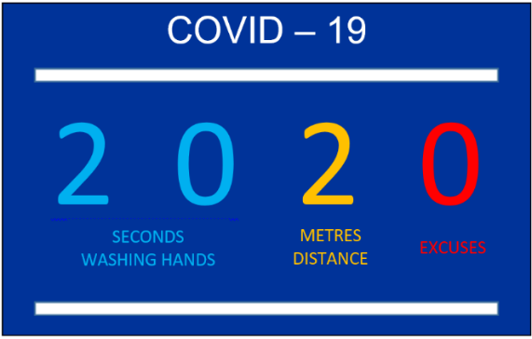
New guidance launched to help get Brits safely back to work
New guidelines are available to UK employers to help them get their businesses back up and running and workplaces operating as safely as possible.
5 key points have been developed and should be implemented as soon as practical. It is expected the guidance will be updated over the coming months, but is a place for employers to start on the long path to getting the economy going again.
The guidance applies to businesses that are currently open, the following link offers guidance on how these can be achieved https://www.gov.uk/government/news/new-guidance-launched-to-help-get-brits-safely-back-to-work

Do you know anyone who wants to improve their digital skills?
With approx. 7.5 million people currently furloughed across the UK with the scheme being extended until the end of October, why not suggest free courses to your friends, family and employees.
The Skills Toolkit is made up of free online courses, tools and resources to help you improve your digital and numeracy skills. There are courses that will give you an introduction to getting confident online to a more advanced digital skills for use in the workplace. These are all short courses that can be completed at home, in your own time, at your own pace.

For full details of the courses available follow https://theskillstoolkit.campaign.gov.uk/

Coronavirus – Back to Work Webinar – Thursday 21st May commencing at 14:00
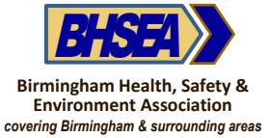
The webinar is being hosted by the Birmingham Health, Safety & Environmental Association and is free for all Safety Group’s members to attend.
The webinar includes practical guidance and best practice for implementing the government guidelines on coronavirus infection controls and will explore:
- A risk-based approach to implementing risk controls that are both effective and practical
- Best practice case studies
- Ideas for making your exit from the lockdown effective whilst minimising disruption Places on this free training webinar are limited and allocated on a first come basis.
For the latest information about the Coronavirus Pandemic
Government advice:
https://www.gov.uk/guidance/coronavirus-covid-19-information-for-the-public
https://www.gov.uk/government/publications/guidance-to-employers-and-businesses-about-covid-19

NHS advice: https://www.nhs.uk/conditions/coronavirus-covid-19
NHS 111 on line advice: https://111.nhs.uk/covid-19 or Telephone 111

Further guidance and support can be found at the following
www.citizensadvice.org.uk Phone: Advice Line: 03444 111 444
www.mind.org.uk Phone: 0300 123 3393
www.anxietyuk.org.uk Phone: 0300 123 3393
www.samaritans.org.uk Phone: 116 123 (free 24-hour helpline)

STAY ALERT > CONTROL THE VIRUS > SAVE LIVES

If you are interested then please drop me an e-mail and I will forward the link for you to register.

