North Lincs Health & Safety Group - COVID-19 Update No 5 Friday 24th April 2020
During the Downing Street press conference on Tues 21st April, the Health Secretary and the Deputy Chief Medical Officer stated that the Government plan to flatten the curve is working but there is still further work to be done. It was stressed that the lockdown will not be lifted until there is no risk of a second peak of the infection. Until then the message remains clear to continue to follow the restrictions in place, to stay at home, protect the NHS and save lives.

Government launches new coronavirus business support finder tool
A new Coronavirus support finder tool has been developed to help businesses and self-employed people across the UK to quickly and easily determine what financial support is available to them during the coronavirus pandemic. The Chancellor confirmed during a press conference this week that he has extended the Furlough scheme until the end of June and also advised that it could be extended further if required.
https://www.gov.uk/government/news/government-launches-new-coronavirus-business-support-finder-tool?utm_source=72ee83f6-faee-4c8e-989f-b7acc873bc8c&utm_medium=email&utm_campaign=govuk-notifications&utm_content=daily
Lone Working

As an employer, you must manage any health and safety risks before people can work alone, these risks include the individual’s health, safety, wellbeing, mental health and their physical health. The same health and safety responsibilities apply for home workers.
When someone is working from home, permanently or temporarily, as an employer you should consider:
- How will you keep in touch with them?
- What work activity will they be doing (and for how long)?
- Can it be done safely?
- Do you need to put control measures in place to protect them?
Further information covering lone working and how support employees working from home are available at https://www.hse.gov.uk/lone-working/employer/manage-the-risks-of-working-alone.htm.
INDG73 - Protecting Lone Workers: How to control the risks of working alone is also available, which can be downloaded free of charge at https://www.hse.gov.uk/pubns/indg73.htm

Examination and testing of lifting and pressure equipment during the outbreak
The HSE recognises the potential challenges when carrying out legal requirements for thorough examination and testing of plant and equipment as a result of additional precautions people need to take to help reduce risk of transmission of coronavirus (COVID-19).
The law for Lifting Operations and Lifting Equipment Regulations (LOLER) and Pressure Systems Safety Regulations (PSSR) remain in place.
The link below contains advice to help duty holders ensure that their work plant and equipment remain safe to use. It helps to guide decision making to see if TE&T requirements can still be met.
https://www.hse.gov.uk/news/work-equipment-coronavirus.htm?utm_source=govdelivery&utm_medium=email&utm_campaign=coronavirus&utm_term=work-equipment-1&utm_content=digest-22-apr-20

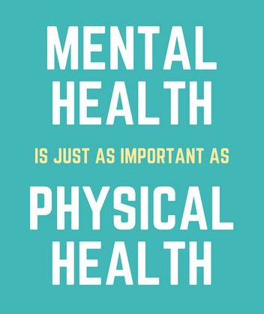
Mental wellbeing while staying at home
Taking care of your mind as well as your body is really important while staying at home because of coronavirus. The links below offer advice on how to keep your mind engaged during the lockdown restrictions and some could even be useful once normal working patterns resume.
https://www.nhs.uk/oneyou/every-mind-matters/coronavirus-covid-19-staying-at-home-tips/
https://www.gov.uk/government/news/covid-19-mental-health-campaign-launches

The extended COVID‐19 lockdown measures may increase levels of anxiety and worry for many different reasons. It is important to remember that these feelings and concerns are perfectly normal and there are numerous support networks able to provide support, contact details for a few of these are detailed below.

www.citizensadvice.org.uk Phone: Advice Line: 03444 111 444 (Monday to Friday, 9am to 5pm)
www.mind.org.uk Phone: 0300 123 3393 (Monday to Friday, 9am to 6pm)
www.anxietyuk.org.uk Phone: 0300 123 3393 (Monday to Friday, 9am to 6pm)
www.samaritans.org.uk Phone: 116 123 (free 24-hour helpline)

For the latest information about the Coronavirus Pandemic

Government advice:
https://www.gov.uk/guidance/coronavirus-covid-19-information-for-the-public
https://www.gov.uk/government/publications/guidance-to-employers-and-businesses-about-covid-19

NHS advice: https://www.nhs.uk/conditions/coronavirus-covid-19
Advice for travellers: https://www.nhs.uk/conditions/coronavirus-covid-19/advice-for-travellers
NHS 111 on line advice: https://111.nhs.uk/covid-19 or Telephone 111

